RETO INDRA

# API GATEWAY

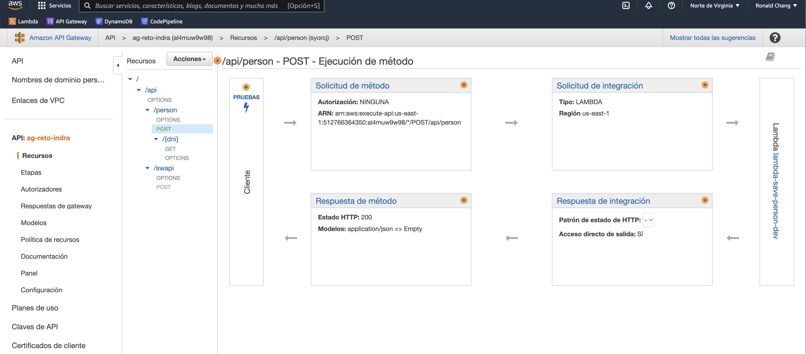

Ver la documentacion en:

<https://app.swaggerhub.com/apis/greipcompany/ag-reto_indra/v2>

# PRUEBAS UNITARIAS

## POST para guardar una persona en

<https://al4muw9w98.execute-api.us-east-1.amazonaws.com/v1/api/person>

REQUEST:

{

"dni": "20202020",

"nombre": "Felix",

"apellido_paterno": "Perez",

"telefono": "987718754",

"email": "fperez@gmail.com",

"edad": "20"

}

RESPONSE:

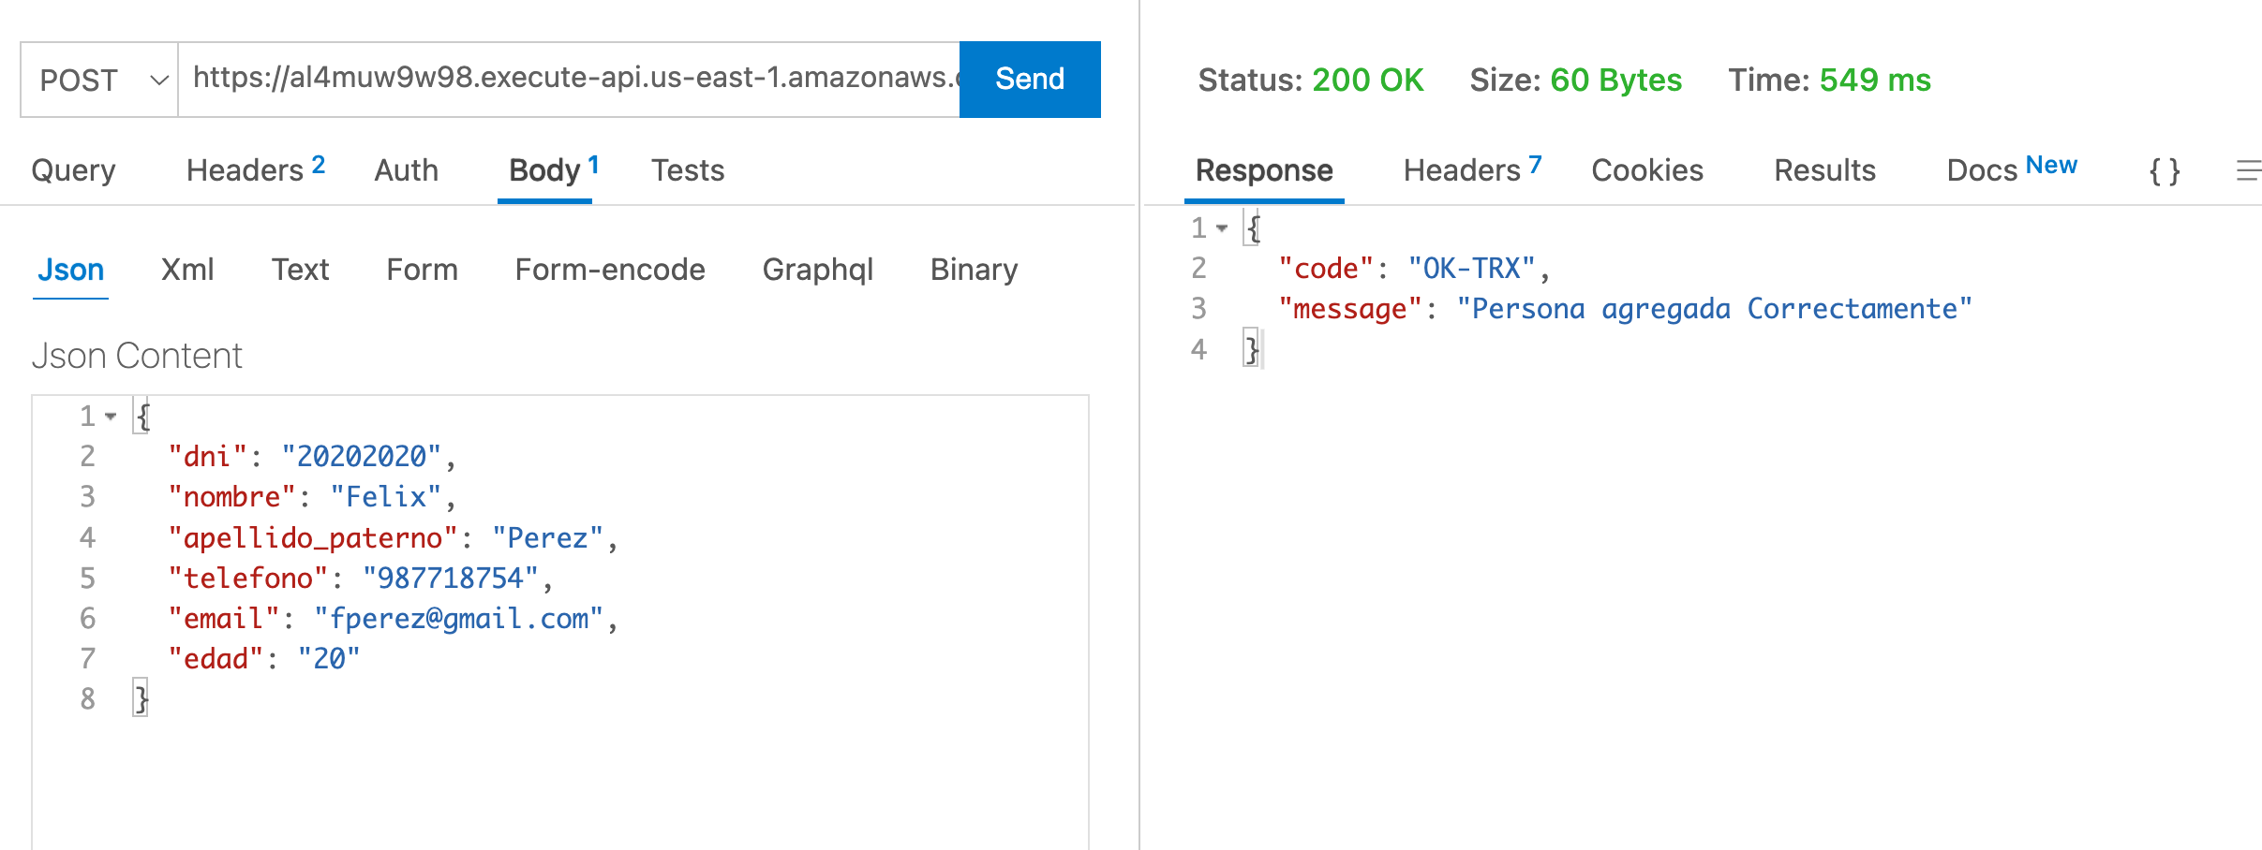

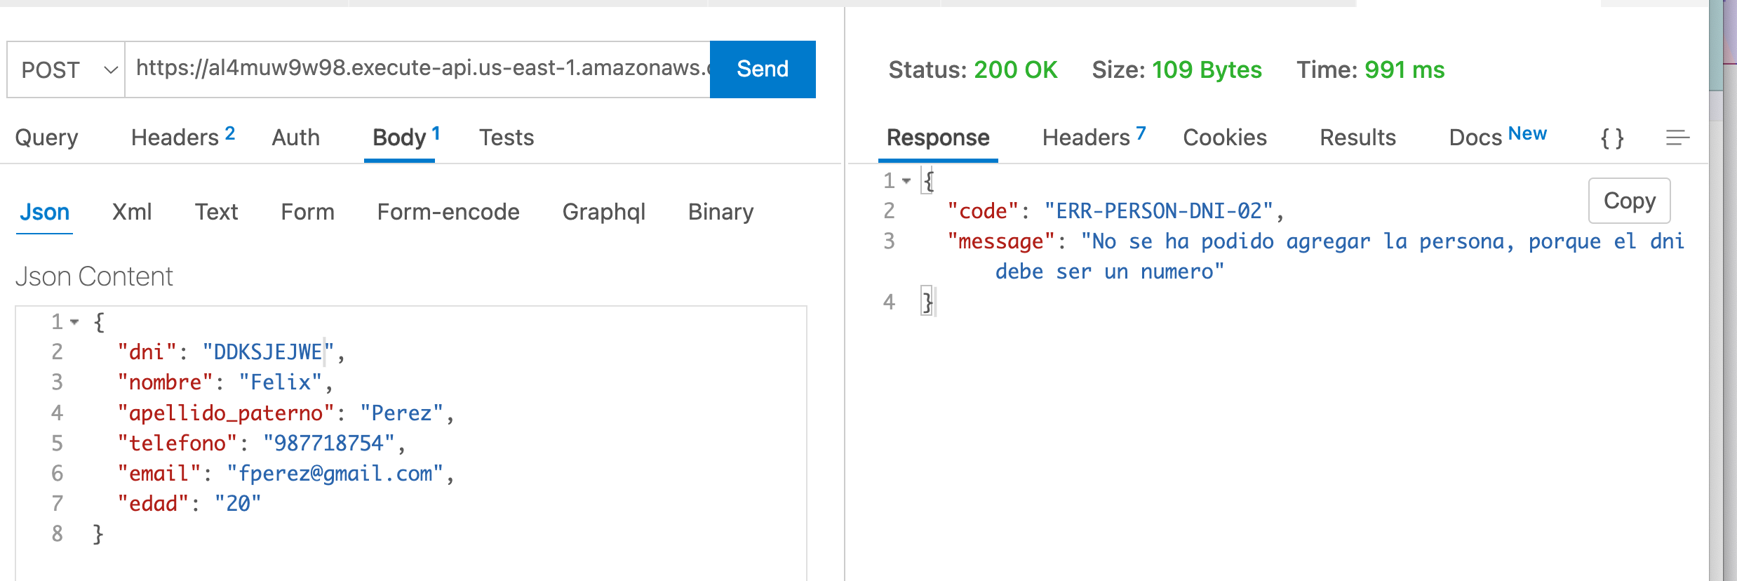

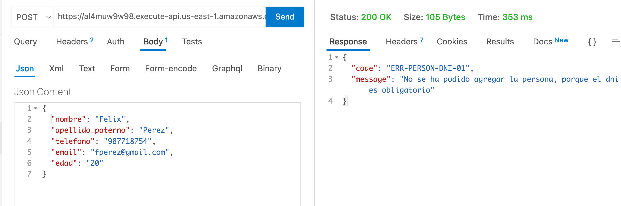

## GET para obtener una persona Guardada

<https://al4muw9w98.execute-api.us-east-1.amazonaws.com/v1/api/person/20202020>

RESPONSE:

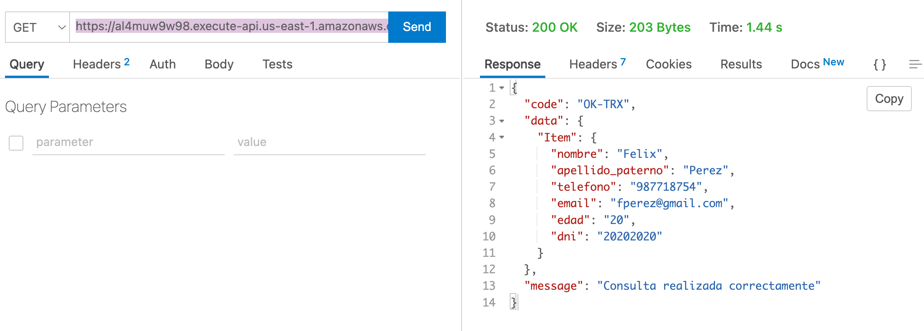

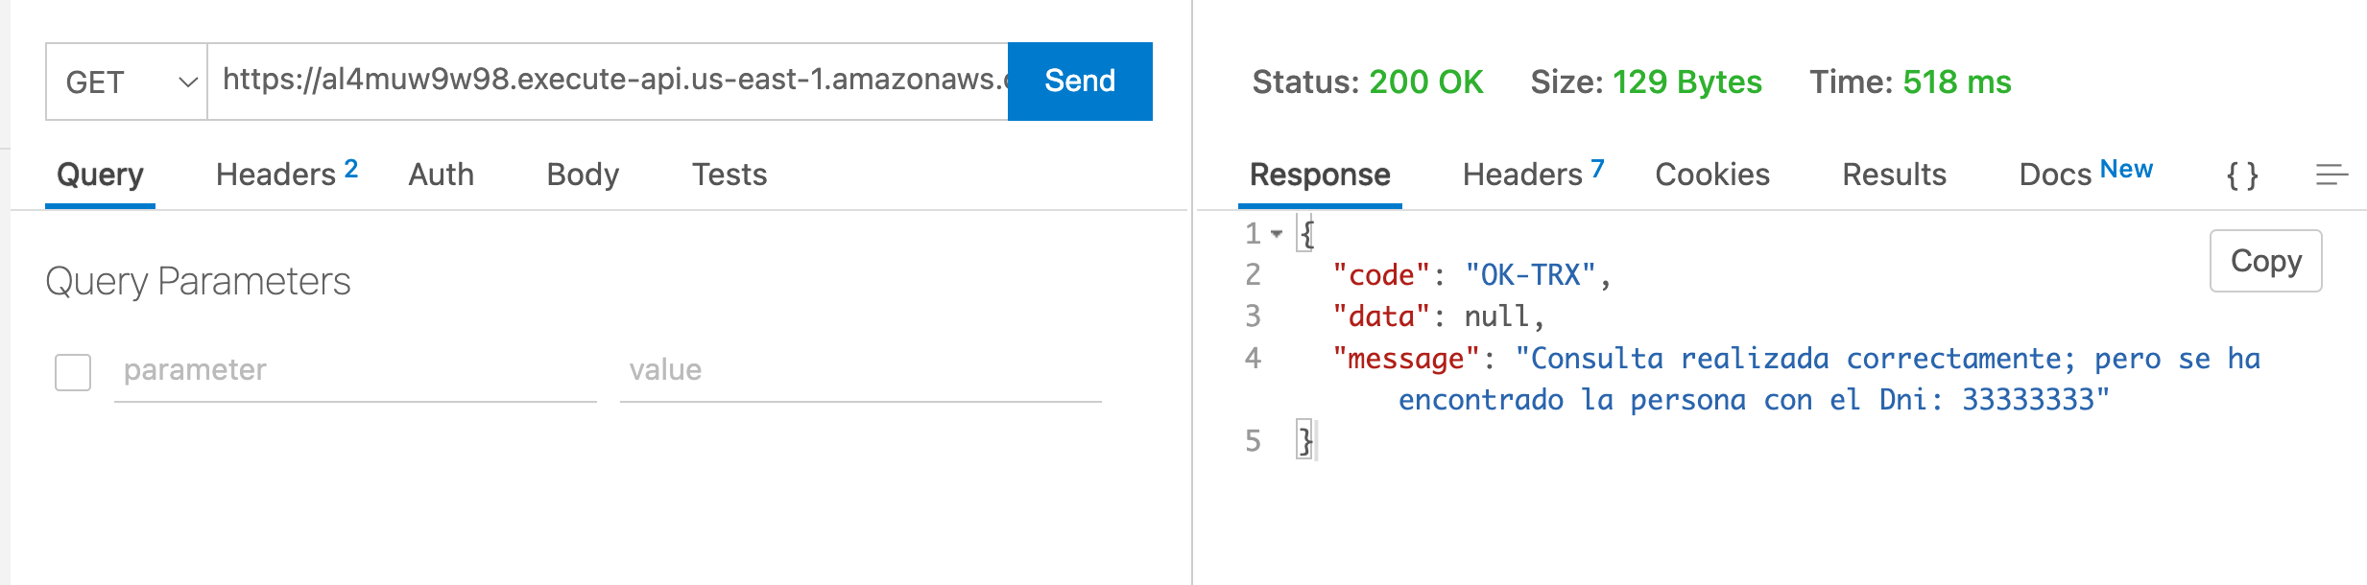

## Integracion con SWAPI

<https://al4muw9w98.execute-api.us-east-1.amazonaws.com/v1/api/swapi>

REQUEST:

{

"schema": "people",

"id": "4"

}

Nota: Solo del schema people se ha traducido sus atributos al español.

RESPONSE:

